**EXPERIMENT – 11**

**AIM** – WRITE VHDL CODE FOR BCD TO EXCESS-3 CONVERTER AND SIMULATE IT

USING MODELSIM.

**THEORY** -BCD stands for Binary Coded Decimal and to convert it to EXCESS-3 we

need to add 0110 to the corresponding digit that needs to be converted

so that we can obtain the EXCESS-3 CODE. It’s a kind of encoder.

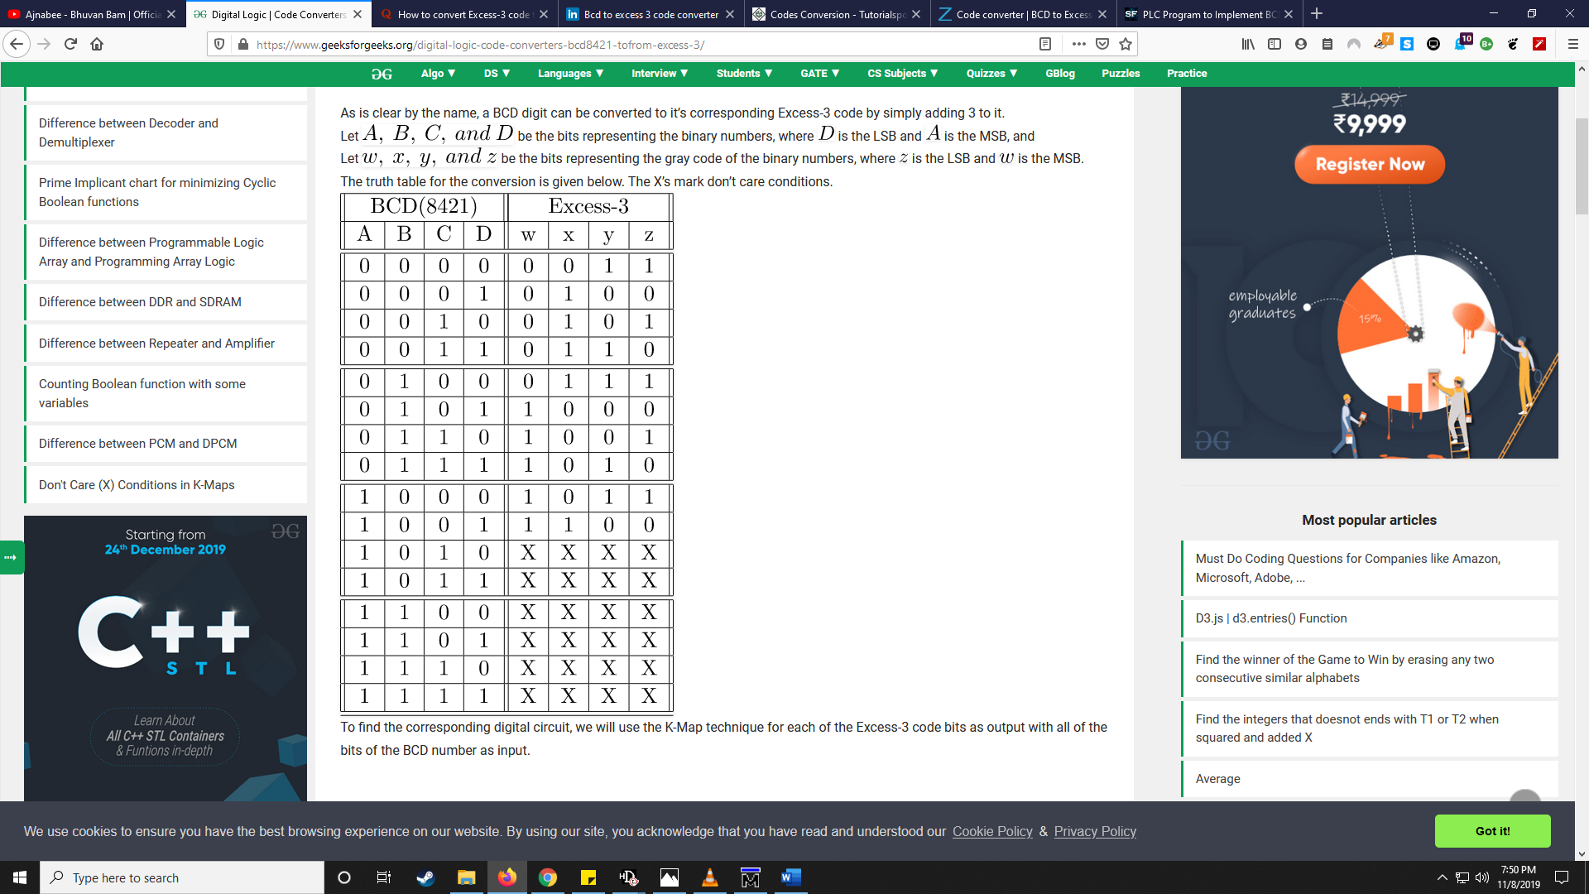

**TRUTH TABLE**

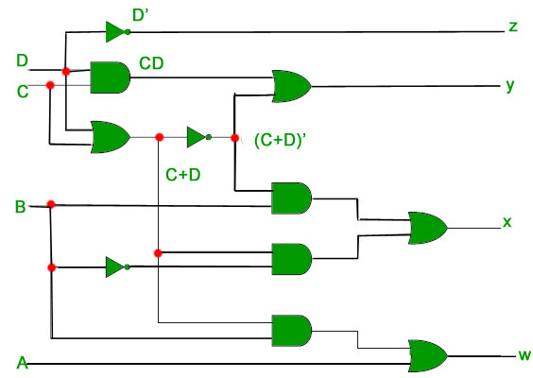

**DIAGRAM**

**VHDL CODE:**

LIBRARY ieee;

USE ieee.std_logic_1164.all;

USE ieee.std_logic_arith.all;

Use Ieee.std_logic_unsigned.all;

ENTITY BCD_EXCESS3 IS

port(A:in std_logic_vector(3 downto 0 ) ;Z:out std_logic_vector(3 downto 0 ) );

END ENTITY BCD_EXCESS3;

--

ARCHITECTURE BCD_EXCESS3_DATAFLOW OF BCD_EXCESS3 IS

BEGIN

Z(3)<= (A(3) OR (A(2) and A(1)) OR (A(2) and A(0)));

Z(2)<= ( ( (not A(2)) and A(1) ) OR ( (not A(2)) and A(0)) OR ( A(2) and ( not A(1) ) and (not A(0) ) ) );

Z(1)<= ((A(1) and A(0)) OR ((not A(1)) and (not A(0)) ) );

Z(0)<= not A(0);

END ARCHITECTURE BCD_EXCESS3_DATAFLOW;

**RESULT:**

